Task 1

#include <iostream>

using namespace std ;

int main(){

for(int a=1; a<=150 ; a++){

if(a%10==0){ // if a is divided by 10 and the remainder is 0 then it will not take the number

continue ;

} cout<< i <<" " ;

}

}

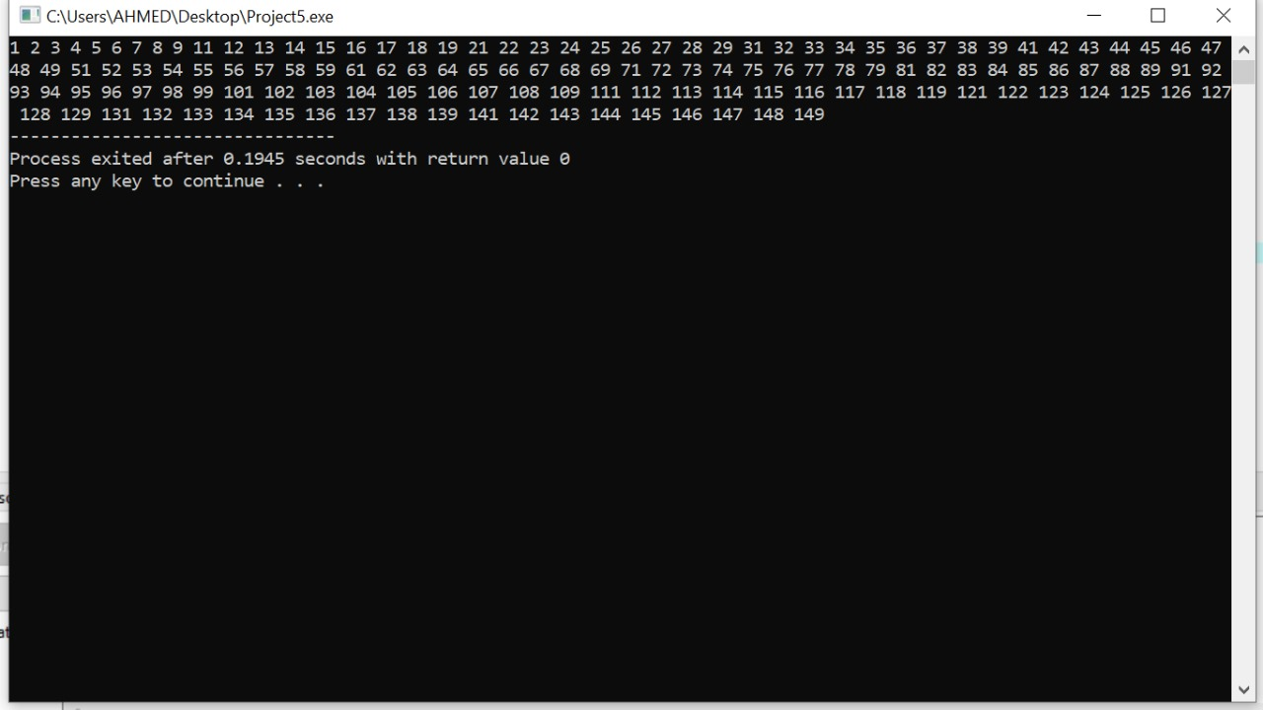

Task 2

int main(){

int a,sum=0;

cout <<"enter the number";

cin>> a ;

while(a>0){

sum=sum+a%10;

a=a/10;

}

cout<<a;

return 0;

}

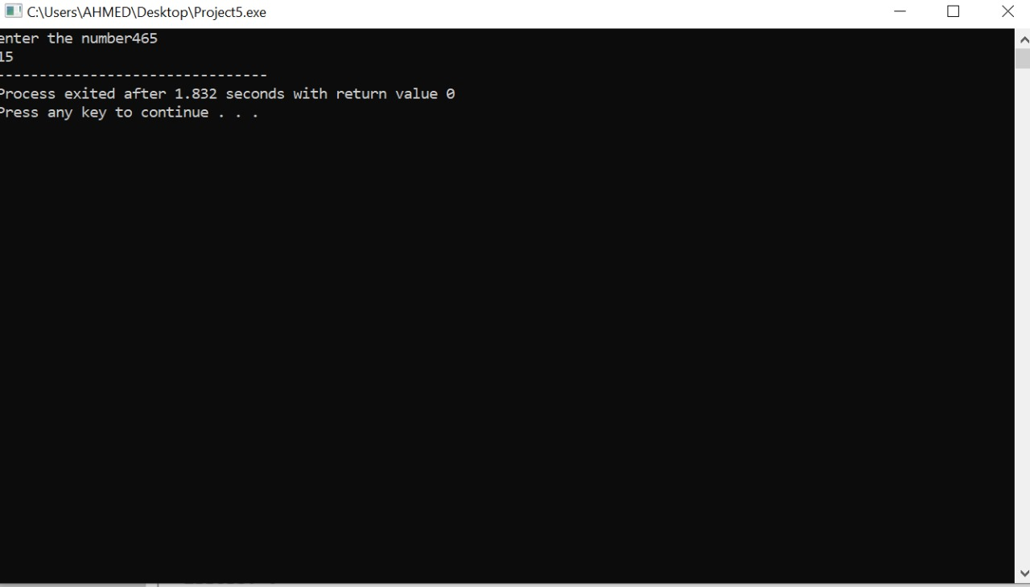

Task 3

int main() {

int num,a=0,b ;

cout<<"enter a positive number";

cin>> num ;

for(int i=1;i<=num;i++){

b=num%i;

if(b==0)

{ a++ ;

}

} if(a!=2)

{ cout<<"the number is not a prime number";

}

else if (a==2){

cout<<"number is a prime number";

}

return 0;

}

